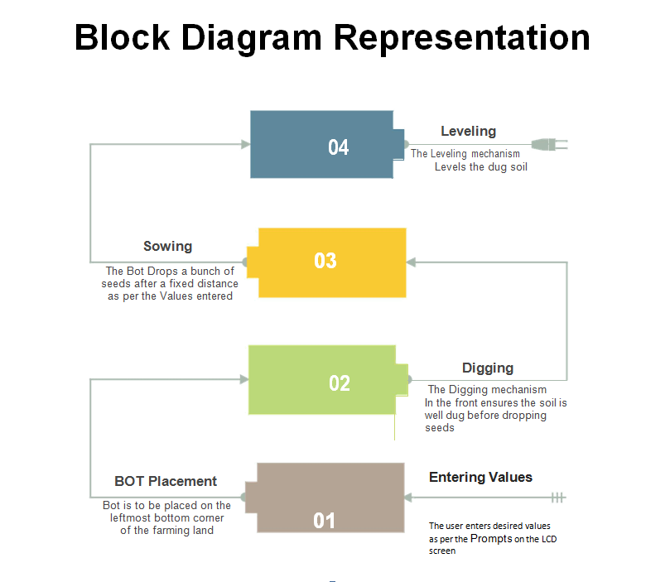

Repeats in accordance to the number of columns

